**Handwritten digit Recognition**

**Abstract**

This project focuses on developing and comparing machine learning models for handwritten digit recognition using the MNIST dataset. The project includes preprocessing steps to prepare the data, training models to classify digits, and evaluating their performance. 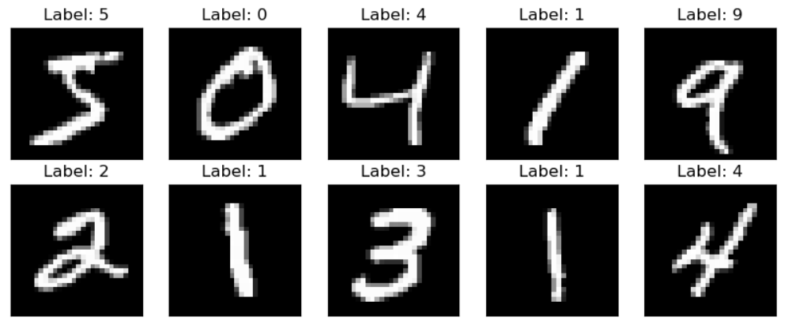

# ****Project Description****

The project has done in 2 different ways one is by using CNN (Convolutional Neural Networks) deep learning framework and another one is by using SVM(Support vector machine) and both follows same workflow that includes the following steps:

1. **Data Loading and Exploration**: we load the mnist dataset from online directly from tensorflow keras datasets.
2. **Data Preprocessing**: Training set contains a total of 60,000 images so, inorder to give it to the model we preprocess it by reshaping those images and decreases the pixels
3. **Flattening images**: For CNN we used Conv2D ,Maxpooling to make a 1 dimensional array format of those images and in SVM we used reshaping and encoding for flattening images and to convert categorical labels
4. **Applying model**: In case of SVM model with a radial basis function (RBF) kernel is created and trained on the training data. The model is configured with appropriate hyperparameters such as C and gamma. And the model is compiled with categorical cross-entropy loss, Adam optimizer, and accuracy metric for CNN
5. **Accuracy:** Calculate accuracy on the test set
6. **External Inputs**: Take some example images containing white colored images on black background and preprocess them before giving it to the model and get predictions .

# ****Technologies and Platforms Used****

1. **Platform**: Jupyter Notebook
2. **Libraries Required for CNN**:
   * numpy
   * tensorflow
   * matplotlib
   * cv2
   * os
3. **Libraries Required for SVM**:
   * numpy
   * tensorflow
   * matplotlib
   * cv2
   * os
   * scikit-learn

# ****DATASET****

# mnist dataset is loaded dynamically by using tensorflow keras datasets

# for external mnist dataset and testing images please click [here](https://www.kaggle.com/datasets/eswarkarthikk/hand-written-digits?select=digits)

# Code Files

# hand written digit recognition using cnn.ipynb

# 2. hand written digit recognition using svm.ipynb